Interviewing and being interviewed - ANSWERS
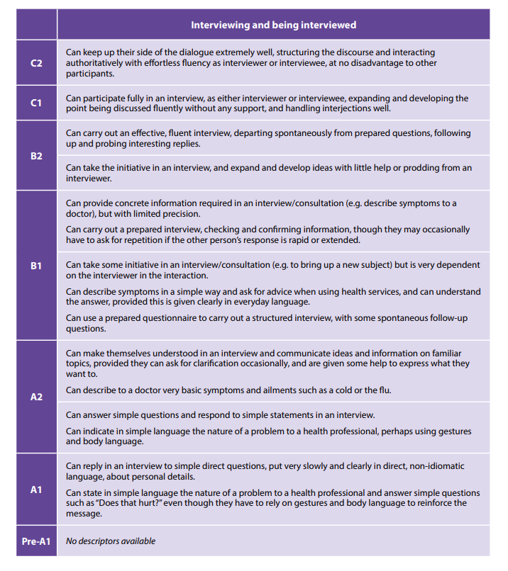
(Council of Europe, 2020, p.80)

