Didacta 2025, Florence, Italy

Handout

Using the CEFR CV Interaction and Mediation descriptors to inform integrated skills task development

Dr Carolyn Westbrook, SFHEA

Test Development Researcher, British Council

Task 1: CEFR CV Familiarisation task

Interaction scale: Informal discussion (with friends)
Complete the table by matching the CEFR level from the box below to the corresponding descriptors.
A1 A2 B1 B2 C1 C2

CEFR Level | Descriptor
- Can keep up with an animated discussion between proficient users of the target language.
- Can express their ideas and opinions with precision, and present and respond to complex lines of argument convincingly.
- Can take an active part in informal discussion in familiar contexts, commenting, putting a point of view clearly, evaluating alternative proposals and making and responding to hypotheses.
- Can with some effort catch much of what is said around them in discussion, but may find it difficult to participate effectively in discussion with several users of the target language who do not modify their language in any way.
- Can account for and sustain their opinions in discussion by providing relevant explanations, arguments and comments.
 | - Can exchange likes and dislikes for sports, foods, etc., using a limited repertoire of expressions, when addressed clearly, slowly and directly.
Pre-A1 | - No descriptor available.
 | - Can easily follow and contribute to complex interactions between third parties in group discussion even on abstract, complex unfamiliar topics.
- Can follow much of what is said around them on general topics, provided interlocutors avoid very idiomatic usage and articulate clearly.
- Can express their thoughts about abstract or cultural topics such as music or films.
- Can explain why something is a problem.
- Can give brief comments on the views of others.
- Can compare and contrast alternatives, discussing what to do, where to go, who or which to choose, etc.
- Can generally follow the main points in an informal discussion with friends provided they articulate clearly in standard language or a familiar variety.
- Can give or seek personal views and opinions in discussing topics of interest.
- Can make their opinions and reactions understood as regards solutions to problems or practical questions of where to go, what to do, or how to organise an event (e.g. an outing).
- Can express beliefs, opinions and agreement and disagreement politely.
 | - Can advise on or discuss sensitive issues without awkwardness, understanding colloquial references and dealing diplomatically with disagreement and criticism.
- Can generally identify the topic of discussion around them when it is conducted slowly and clearly.
- Can exchange opinions and compare things and people using simple language.
- Can discuss what to do in the evening or at the weekend.
- Can make and respond to suggestions.
- Can agree and disagree with others.
- Can discuss everyday practical issues in a simple way when addressed clearly, slowly and directly.
- Can discuss what to do, where to go and make arrangements to meet.
- Can express opinions in a limited way.

CEFR Companion Volume: Informal discussion scale
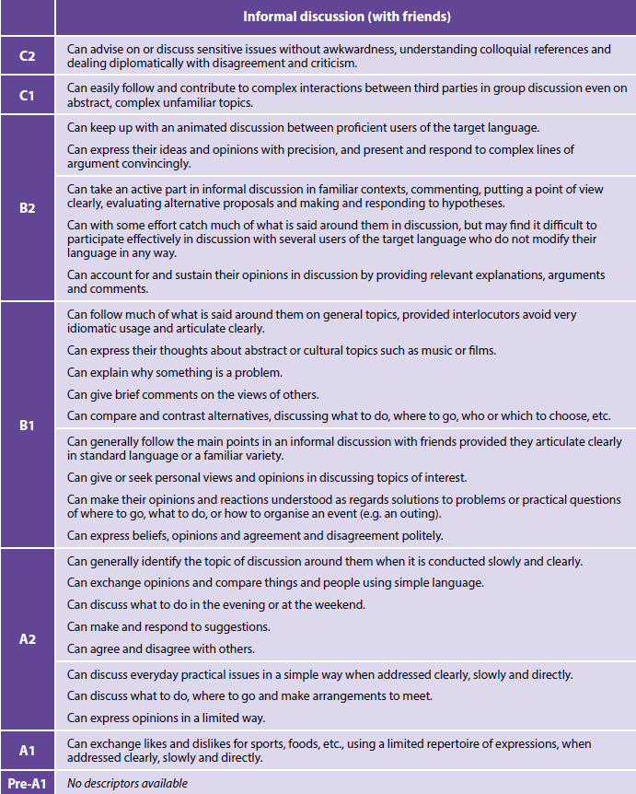
(Council of Europe, 2020, p.75)

Task 2: CEFR CV Familiarisation task 2

Mediation scale: Explaining data (in graphs, diagrams, etc.)
Complete the table by matching the CEFR level from the box below to the corresponding descriptors.
A2 B1 B2 C1 C2

CEFR Level | Descriptor
 | - Can interpret and describe (in Language B) detailed information in diagrams in their fields of interest (with text in Language A), even though lexical gaps may cause hesitation or imprecise formulation.
 | - Can interpret and describe (in Language B) overall trends shown in simple diagrams (e.g. graphs, bar charts) (with text in Language A), even though lexical limitations cause difficulty with formulation at times.
A1 | - No descriptors available.
 | - Can interpret and describe clearly and reliably (in Language B) the salient points and details contained in complex diagrams and other visually organised information (with text in Language A) on complex academic or professional topics.
Pre-A1 | - No descriptors available.
A2 | - Can interpret and describe (in Language B) simple visuals on familiar topics (e.g. a weather map, a basic flow chart) (with text in Language A), even though pauses, false starts and reformulation may be very evident.
A2 | - No descriptors available.
 | - Can interpret and describe clearly and reliably (in Language B) various forms of empirical data and visually organised information (with text in Language A) from conceptually complex research concerning academic or professional topics.
 | - Can interpret and describe reliably (in Language B) detailed information contained in complex diagrams, charts and other visually organised information (with text in Language A) on topics in their fields of interest.

CEFR Companion Volume: Explaining data scale

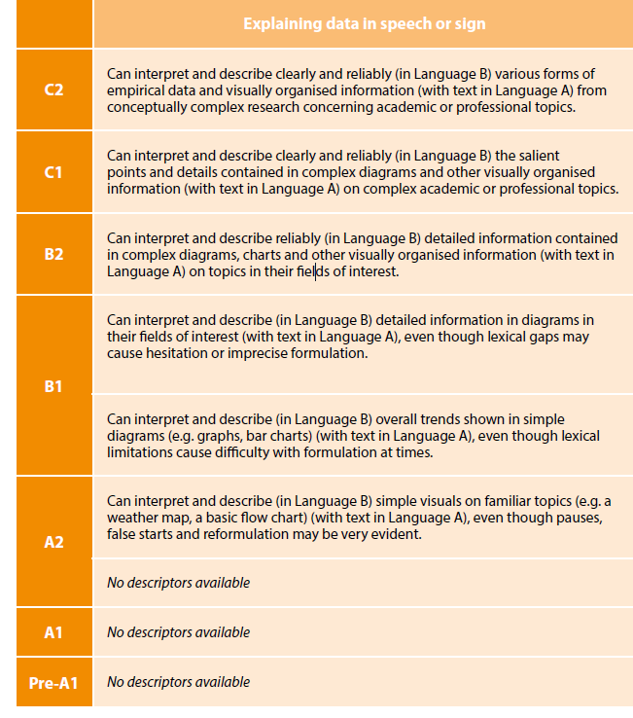

(Council of Europe, 2020, p.97)

